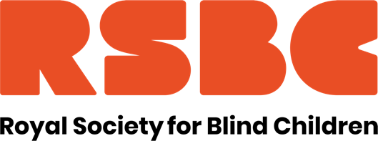

Job Title: Speech and Language Therapist
Reports to: College Leadership Team
FTE: 14 hours per week, term time only
Location: Orpington with some travel to partnership colleges
Salary: Actual salary of £10,806 - £12,443 per annum depending on skills and experience. (Based on Band 6)
Are you interested in working for an organisation making a real difference to the lives of young blind and partially sighted people?
Here at the Royal Society for Blind Children we believe that every blind young person should have the chance to live life without limits. Our values of Trust, Energy, Ambition, and Motivation underpin everything we do, and by giving young people the essential skills to take control of their life, they can unleash their true potential.
We are looking for a Speech and Language Therapist to provide highly specialist SaLT support to the RSBC’s further education students in our education provision. You will be a source of clinical expertise and advice on Speech and Language Therapy and work collaboratively with therapists and other colleagues, students, their families, carers and multi-disciplinary teams to ensure effective interventions & outcomes.

You will make assessments, and independently formulate individualised strategies and plans and implement specialised methods for a wide range of complex conditions, using clinical reasoning, current principles and evidence-based practice and utilising a wide range of expert SaLT techniques, whilst providing informed reports for each student. You will also design and update specific SaLT intervention and support programmes and/or protocols for staff colleagues.

You will be fully qualified, have membership of the HPC, have significant experience of working with young people with complex needs, ability to contribute to multi-disciplined teams, excellent report writing, interpersonal and communication skills and be competent in using a range of ICT software particularly Word, Excel and Outlook.
In return we offer a competitive range of benefits an Employee Assistance Programme, Perkbox retail discounts, 3% contribution towards pension, and a season ticket loan. We are a welcoming, diverse and inclusive workforce and are a Disability Confident Employer. We also hold the Investors in People Silver Award.
For further details on the role, please refer to the Job Description and Person Specification.
https://www.rsbc.org.uk/work-for-us/
Please apply by emailing your CV and a supporting statement which details how you meet the requirements of the role and person spec to recruitment@rsbc.org.uk

Deadline: Apply asap

To apply you will need to have the right to work in the UK

The Society is committed to safeguarding and promoting the welfare of children, young people and adults and expects all staff and volunteers to share this commitment. Therefore, all posts are subject to an Enhanced Disclosure check from the Disclosure and Barring Service and 2 satisfactory professional references. Registered Charity No.307892

