P012 | Complaints and Compliments Policy

Purpose and action

This Policy outlines the Society’s corporate policy and procedure. This Policy is available in other formats on request and provides an on-going reference document for managers and employees.

The contents of this Policy apply to all employees. All employees whether part or full-time are covered by this policy. All employees are required to familiarise themselves with the Policy.

This policy does not form part of an employee’s contract of employment.

Review

The Society will review this policy by the review date specified in the Review section of the control sheet.

Occasionally, legislative changes may require additional changes outside of the designated review date.

The Society reserves the right to amend or alter this policy and associated procedure at any time.

Distribution and enquiries

Access to all policies is via RSBC Policy link from the homepage of the intranet.

Enquires concerning this document including suggestions for change should be made to the Head of HR & Volunteering.

Review and Summary of changes

Date Reviewed | Next Review Date | Summary of Changes
Aug 1999 |  | New Policy
Oct 2008 | Oct 2011 | Reviewed and updated
11/6/2015 | 11/6/2018 | Reviewed, updated with new legislation and reformatted
23/03/17 | 23/7/2019 | Name change from RLSB to RSBC following merger
23-7-19 | 23/7/2022 | Policy Refresh

Authorisation

Author’s job title | Department
Head of HR & Volunteering | HR
This Policy has been reviewed by SLT and is hereby authorised.
Safeguarding and Equality & Diversity issues have been considered and managed as appropriate.
Job Title | Signature |  | Date
Deputy CEO | 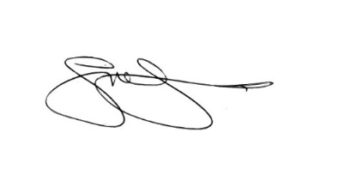 |  | 03/12/19

POLICY

The RSBC is committed to managing complaints efficiently, through thorough investigation and timely and positive responses to those that have cause to complain about our products and services.

We will use the information that emerges from a complaint constructively to improve and enhance our services, or reinforce our links with all our stakeholders.

We will use positive feedback in a similar fashion and ensure that when it is received, the individuals concerned are made aware of compliments received.

SCOPE

All RSBC people.

DEFINITIONS

The Complaints Manager is the Deputy CEO

A complaint is an expression of dissatisfaction made to an organisation, related to its products, services or the complaints handling process itself, where a response or resolution is explicitly or implicitly expected.

REFERENCES

None

PROCEDURE

- Receiving a complaint

The following flowchart summarises the key stages of receiving and logging a complaint.

Complaints may be made verbally (by phone or face to face), by letter or by e-mail. Where initial contact is via telephone or face to face, the key stages of the complaints process are to be explained to the person complaining.

All contact (phone, letter, etc) with the complainant is to be logged on the complaints system, and hard copies of correspondence received should also be filed. This applies throughout the process.
Details of the complaint should be recorded on the standard data gathering form at Appendix A.

During the initial contact with the complainant, the RSBC representative should attempt to establish the outcome they are seeking and record this information. Knowledge of expectations at an early stage is recognised in assisting with rapid and effective resolution of complaints.

Where a concern is received locally by telephone and is dealt with at this initial point of contact, a formal response is not necessary. However, the concern should still be recorded and the action taken recorded. It is anticipated that a significant number of concerns at this level will be dealt with during the initial contact, or via a follow-up call soon after.

All complaints, including those resolved at the initial point of contact must be forwarded to the Complaints Manager.

A copy should also be sent to the CEO office in all cases.

All complaints are to be acknowledged by the Complaints Manager in a covering letter that explains the initial response and timeframe that will be applied. A standard acknowledgement letter is at Appendix B.

The Complaints Manager will identify the most appropriate person to investigate and resolve the complaint and forward all details to them.

- Investigating the complaint

The flowchart on page 6 summarises the key stages to investigating and responding to the complaint.

The investigation may range from a review of actions already taken, to undertaking further investigations and may include possible visits to establish further details relating to the issue.

When conducting the investigation, it is useful to identify the root causes of the complaint. By doing so we can:

- Take corrective action to resolve the complaint
- Take preventative action to prevent it from happening again. Such action may involve changes to working practices and revising policies and procedures.

Once the complaint has been investigated and appropriate actions decided a formal response to the complainant should be made.

This should be drafted by the investigating member of staff and sent to the Complaints Manager with all accompanying paperwork.

The Complaints Manager will formally respond to the complainant and update the Complaints Log.

The complainant will have 10 days to lodge an appeal against the outcome if they are not satisfied.

- Appeal Stage

A flowchart with the key stages of the appeal element of the process is at page 8.

Stage 1 – CEO Appeal

The first stage appeal will be managed by the RSBC CEO. On receipt of the appeal, the Complaints Manager will

- Acknowledge the appeal within 2 working days
- Forward details of the appeal and original complaint to the CEO

The CEO will conduct an investigation into the complaint focusing on:

- has the process been followed correctly?
- are the decisions reached at earlier stage in the process consistent with the available evidence and take into account all relevant facts?

Once the CEO has reached a conclusion, they will write to the complainant to advise them of their findings. This letter should be copied to the Complaints Manager who will update the Complaint Log.

The CEO will advise line management of any actions to be taken.

Stage 2 – Trustee/Governors’ Appeal

Should the complainant remain dissatisfied, they have a further period of 10 working days to inform the CEO they wish to escalate their appeal. This notification must include the reasons for their appeal in order to maintain clarity and ensure the final stage of the process is efficiently run. Acceptable reasons would relate to:

- Failure to follow the prescribed process
- Inappropriate decision given the facts of the appeal, or
- Relevant facts have been ignored or given inappropriate weight.

This is the final stage of the appeal process.

Information from the previous stages of the process will be passed from the Complaints Manager to the Board of Trustees/Governors. The focus of the Trustees/Governors will be to examine:

- has the process been followed correctly?
- are the decisions reached at earlier stage in the process consistent with the available evidence and take into account all relevant facts?

The complainant is to be notified within 15 working days of receipt of the appeal request of the date of the next Trustees or Governors meeting and advised that all reasonable and receipted travelling expenses, including those of any supporter will be reimbursed should they wish to attend.

Appendix A

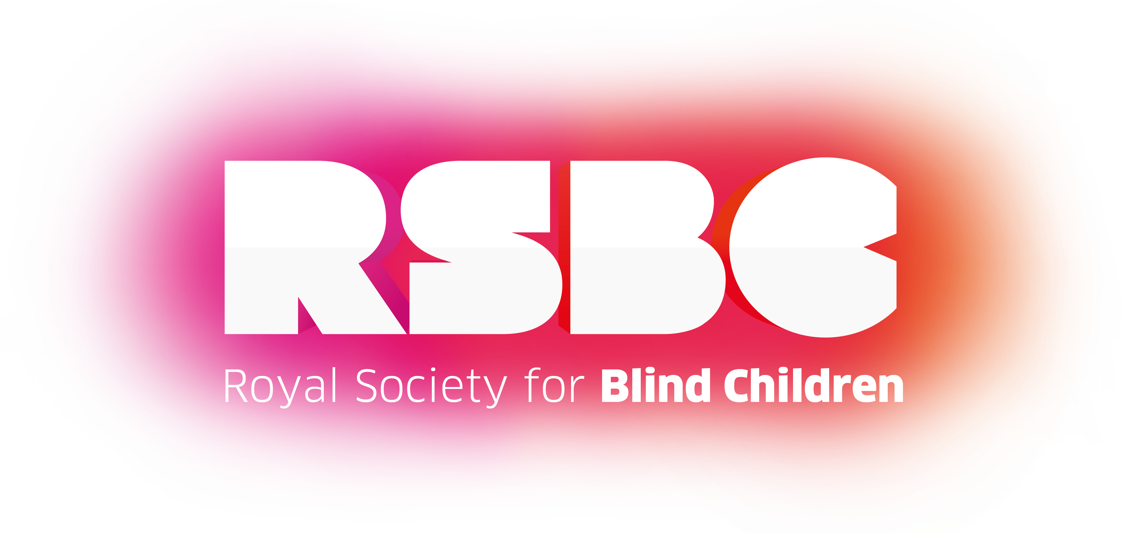

ROYAL SOCIETY FOR BLIND CHILDREN

COMPLIMENTS AND COMPLAINTS

The Royal Society for Blind Children welcomes your views, so please take time to complete this form if there is anything that you would like to bring to our attention.

Compliment Date

Complaint Name

Comments Contact Details

Please give details

If you would like a response please give contact details

Appendix B

Complaint re:

Dear ..............

I am writing to acknowledge receipt of your complaint and outline the steps that we will now be taking to bring this matter to a mutually satisfactory conclusion.

Our policy is to investigate all complaints and we value the opportunity to build a stronger relationship with you and use the information that emerges from a complaint constructively to improve and enhance our services.

The following process will apply:

- Your complaint will be investigated and a written response will be sent to you within 7 working days of the receipt of your complaint.

- The response will, where possible, explain the findings and conclusions and, if appropriate, indicate the action that will be taken.

- Where it is not possible to being the matter to a conclusion within 7 working days, you will be advised to that effect and be given an indication of the likely response time. You will be updated on a regular basis of progress.

- If you are not happy with the outcome, you can appeal and the matter will be referred to the Chief Executive.

Yours sincerely,

Safety & Equality Impact Assessment Template
1) What is being assessed?
a) Is this a policy or procedure? | Policy and Procedure
c) Is it new or existing? | Existing
2.a) what are the aims and objectives of the policy or function? | Advise staff/ workers/ service users/ members of the public of the policy and procedure to follow with regards to complaints or compliments
b) How do they relate to the organisation’s objectives in the strategic plans? | To ensure that we provide the best service possible by improving processes.
c) Whose needs is the policy or function designed to meet? | All Staff
d) What are the current priorities of the policy or function? | To ensure there is a clearly defined process for complaining or leaving compliments that ensures that they are dealt with and recorded
3.a) in what ways might this policy or service affect some groups of people differently? | None
b) Might some groups find it harder to access the policy/service? | No
c) Do some groups have particular needs that are not well met by the current policy or service? | No
4.a) What evidence do you have for your judgement? | N/a
b) Is there evidence of public concern? E.g. complaints? | No
c) Have staff raised concerns? | No
d) Is there local or national research to suggest that there could be a problem in this area? | N/a
5a) What information exists that the policy or function affects groups differently? (consider all equality strands) | N/a
b) Are there additional groups who may be experiencing adverse or disproportionate impact? (consider carers, low income earners, lone parents, ex-prisoners etc) | N/a
c) What evidence do you have for this? | N/a
d) If you have found evidence of adverse or disproportionate impact, how can this be removed or reduced? | N/a
e) Will further research and/or consultation be required? If yes, what and when? | N/a
6. How will you monitor the take-up or impact of the policy or service in the future? | Monitoring of complaints and compliments schedule
7) What are the conclusions of this assessment regarding
a) Compliance with all relevant equalities legislation? | Compliant
b) Compliance with equalities Codes of Practice? | Compliant
c) Compliance with statutory safeguarding requirements? | Compliant
d) Compliance with Safeguarding Good Practice | Compliant
What other policy/ies should it cross refer to for the purposes of equality and safeguarding? | None
9) What are your final recommendations i.e. areas requiring further action? | N/a
Author’s Job Title |  | Signature | Date
Head of HR & Volunteering |  | 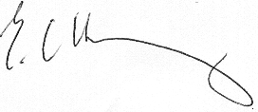 | 23/7/2019

