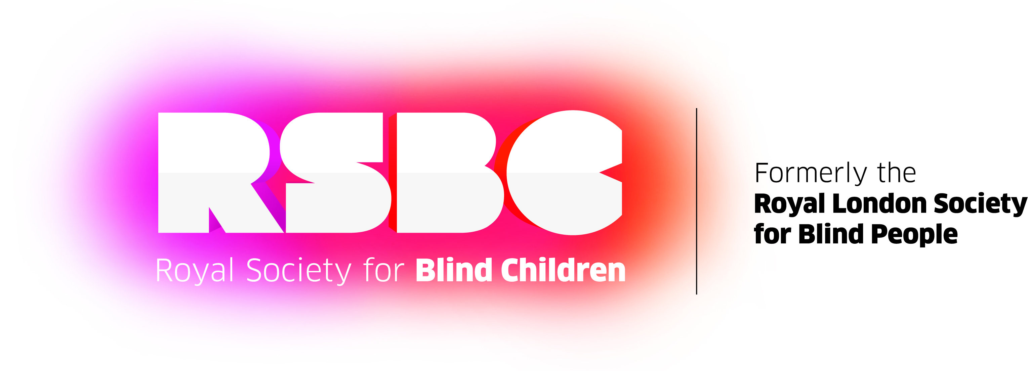
IT’S MORE THAN BEING BLIND
NO BLIND CHILD CAN WAIT
RLSB STRATEGY 2016-19

Foreword
DR. Tom Pey, RLSB Chief Executive:
Blind children and young people can’t wait any longer for the rest of society to catch up with their ambitions.
No blind child can wait has been inspired by a series of frank and open conversations we’ve had with blind young people and their families about the challenges they face and the hopes they have.
We’ve spoken with parents who’ve told us:
“It’s almost like bereavement when you find out they are visually impaired, like letting go of the child that you thought you would have.”
“To keep him safe we had to live in isolation.”
Teenagers we work with have said:
“I find it hard to make friends. People didn’t understand my vision impairment.”
“My school career advisor said I couldn’t go to university because I am blind.”
When we looked back 177 years ago to when we were founded we concluded that this was how blind young people felt then. Our sadness at how little had changed over nearly two centuries ignited a determination in us that we would do things differently so as to ensure that no blind child should have to live a life of exclusion and poverty ever again.
Blind young people deserve root and branch reform to our thinking, our approach and our services if we were to truly unlock the inner strength and potential that will sustain them as they grow up.
So, this strategy sets about unlocking the inner strength that resides in all of us; that sustains us in difficult times, takes us through the everyday and inspires us to do things hitherto thought impossible. In short, our strategy sets out to ensure that all blind children, young people and their families live a Life without Limits.

DR. Tom Pey
November 2015

Our Vision
“No blind child in the UK will live a life of exclusion or poverty.”
Our Mission
If a blind child needs our help anywhere in England & Wales, we will be there with real friendship and expert support for them and their family to enable them to take full advantage of what life offers.

It is every parent’s wish that their child develops skills and confidence to make their way in life. We are the only charity in the UK where services are designed to support the whole family on this journey and where the parent, whenever possible, is at the centre of the child’s development.

Given the limitations of our resources, in five years’ time we will support half of these children and families and in 10 years we aim to support all those who need us.

To achieve this we will

Double our income in five years and doubling it again in 10 years, using those funds to:

- Provide expert family support services and comprehensive advice and information for the child and family throughout the child’s development.
- Help blind children and young people build friendships and confidence through community based opportunities that enable them and their parents to meet individually and collectively, through a range of services.
- Build a mainstream education programme that acts as a beacon for similar establishments in the UK to offer inclusive mainstream opportunities to other vision impaired children.
- Provide employment and employability skills services aimed at reducing unemployment and poverty levels.
- Partner with experts to develop or build technology solutions for those we serve.
- Build a Life without Limits centre that will be a hub for delivery for our services and a lighthouse for world class research and innovation.
Expertise and innovation at our core

Innovation and continuous improvement will be at the heart of what we do. Underpinning all of our services and core to delivering the charity’s desired outcomes, will be a therapeutic family and child development approach which will always be based on scientific research and best practice.

An infrastructure that supports success
To achieve success we must attract and retain the right people. We will:
- Recruit and retain an employed, volunteer and trustee team who excel in their work.
- Develop our people, our volunteers and trustees.
- Partner with leaders in their fields to develop and deliver our services.
- In addition, we will continuously improve our processes and systems to support our people to out-perform every other charity in our sector in relation to outcomes, quality and cost.
Success built on strong values

Blind children and their families will always come first in everything we do and to support us on our journey, we will live our values of:

TRUST: accountable and responsible. Respect for each other.

ENERGY: straight talking. Constantly learning and innovating.

AMBITION: confronting reality. Deliver results, working to highest standards.

MOTIVATION: vision impaired children are our No 1 priority. Solutions, not problems.

The Royal Society for Blind Children (RSBC) | 52 – 58 Arcola Street, London, E8 2DJ | t: 020 3198 0225 w: rsbc.org.uk e: enquiries@rsbc.org.uk
Registered Charity Number: 307892

